جامعة المنوفية
كلية الحاسبات والمعلومات
2026-2027
Menofyia University
System Analysis & design Project
second year
2026-2027


No. | Name | ID
1 | معاذ محمد عبد العظيم بدير | 190450

Smart Waste Collection Scheduling System (pickup requests)

Planning (Project Plan)

Project Identification
Project Name:
Smart Waste Collection Scheduling System (pickup requests)
Current Problem:
- Waste pickup requests on campus are handled manually, making them difficult to organize and track.
- Poor coordination of collection schedules can cause delayed pickups and waste accumulation.
- Students and staff have limited incentives to separate recyclable materials from general waste.
- There is no centralized record of collected materials, verified weights, and recycling participation.

Description of project:
The proposed system is a web-based platform for managing waste collection and encouraging recycling within a university campus. Students and staff can submit pickup requests by specifying the location, material type, and estimated quantity, then track their request status. Administrators can schedule pickups and assign collection workers. Workers record the actual weight of accepted recyclable materials and confirm collection. The system awards points only after collection is verified, allowing users to redeem their points for available rewards. Administrators can also view reports on pickup requests, collected materials, and recycling participation.

System Request

System Request
Project Sponsor: | Faculty of Computers and Information, Menoufia University.
Business Need: | 1. Organize campus waste collection and reduce pickup delays.  2. Encourage students and staff to recycle.  3. Maintain accurate collection records.
Business Requirements: | 1. Allow users to submit and track pickup requests.  2. Schedule pickups, assign workers, and record verified weights.  3. Award and redeem recycling points, and generate reports.
Business Value: | 1. Save time and improve staff coordination.  2. Increase recycling participation and reduce waste accumulation.  3. Support decisions through accurate reports.
Special Issues or Constraints: | 1. Serve one campus within the course deadline and available resources.  2. Award points only once per verified collection; provide rewards within budget.  3. Protect personal data and restrict access by user role.

Feasibility Analysis
Technical Feasibility
- The system can be developed using HTML, CSS, JavaScript, Java Servlets, and MySQL.
- Users can access the system through a web browser on a computer or smartphone.
- Collection workers need a weighing scale to verify recyclable material weights.
- The initial version does not require smart sensors or specialized hardware beyond a weighing scale.
Economic Feasibility
  - Free development tools can reduce the initial development cost.
  - Expected costs include hosting, maintenance, weighing equipment, and recycling rewards.
  - Better scheduling may reduce staff coordination time and unnecessary collection trips.
  - A small pilot can help assess whether the expected benefits justify the costs.
Organizational Feasibility
- Faculty approval and support are required.
- An administrator and collection workers are needed.
- Users and workers need basic training.
- Clear recycling and reward rules must be defined.

Project Methodology

The project will follow the Waterfall methodology:
Its scope is limited to one university campus, and the main requirements are defined in the System Request. Work will proceed through planning, analysis, design, and final documentation. Each phase will be reviewed before starting the next to keep the work organized and reduce rework.

Time Estimation

 | Planning | Analysis | Design | Implementation
Standard percentages | 15% | 20% | 35% | 30%
Estimated time based on planning time | Estimated: 12 days | 16 days | 28 days | 24 days

Tasks Identification
System Request | Name of Task
22/09/2026 | Start Date
23/09/2026 | End Date
Moaaz Beder | Person assigned to task
High | Priority
Microsoft Word, Trello | Resources Needed
4 hours | Estimated Time
 | Actual Time

Feasibility Study | Name of Task
24/09/2026 | Start Date
27/09/2026 | End Date
Moaaz Beder | Person assigned to task
High | Priority
Microsoft Word, Microsoft Excel | Resources Needed
8 hours | Estimated Time
 | Actual Time

Pert Chart, Gantt Chart | Name of Task
28/09/2026 | Start Date
03/10/2026 | End Date
Moaaz Beder | Person assigned to task
High | Priority
Draw.io, Microsoft Excel | Resources Needed
9 hours | Estimated Time
 | Actual Time

Interview | Name of Task
04/10/2026 | Start Date
06/10/2026 | End Date
Moaaz Beder | Person assigned to task
Medium | Priority
Microsoft Word | Resources Needed
6 hours | Estimated Time
 | Actual Time

Questionnaire | Name of Task
07/10/2026 | Start Date
09/10/2026 | End Date
Moaaz Beder | Person assigned to task
Medium | Priority
Google Forms, Microsoft Excel | Resources Needed
5 hours | Estimated Time
 | Actual Time

Data Flow Diagram | Name of Task
10/10/2026 | Start Date
13/10/2026 | End Date
Moaaz Beder | Person assigned to task
High | Priority
Draw.io | Resources Needed
12 hours | Estimated Time
 | Actual Time

Data Store | Name of Task
14/10/2026 | Start Date
15/10/2026 | End Date
Moaaz Beder | Person assigned to task
High | Priority
Microsoft Word | Resources Needed
6 hours | Estimated Time
 | Actual Time

Process Specification | Name of Task
16/10/2026 | Start Date
19/10/2026 | End Date
Moaaz Beder | Person assigned to task
High | Priority
Microsoft Word | Resources Needed
10 hours | Estimated Time
 | Actual Time

Entity Relationship | Name of Task
20/10/2026 | Start Date
23/10/2026 | End Date
Moaaz Beder | Person assigned to task
High | Priority
Draw.io | Resources Needed
10 hours | Estimated Time
 | Actual Time

Normalization | Name of Task
24/10/2026 | Start Date
27/10/2026 | End Date
Moaaz Beder | Person assigned to task
High | Priority
Microsoft Word, Microsoft Excel | Resources Needed
8 hours | Estimated Time
 | Actual Time

Design | Name of Task
28/10/2026 | Start Date
16/11/2026 | End Date
Moaaz Beder | Person assigned to task
High | Priority
Draw.io, Microsoft Word | Resources Needed
40 hours | Estimated Time
 | Actual Time

Implementation | Name of Task
17/11/2026 | Start Date
10/12/2026 | End Date
Moaaz Beder | Person assigned to task
High | Priority
Visual Studio Code, MySQL, Web Browser | Resources Needed
48 hours | Estimated Time
 | Actual Time

Pert Chart
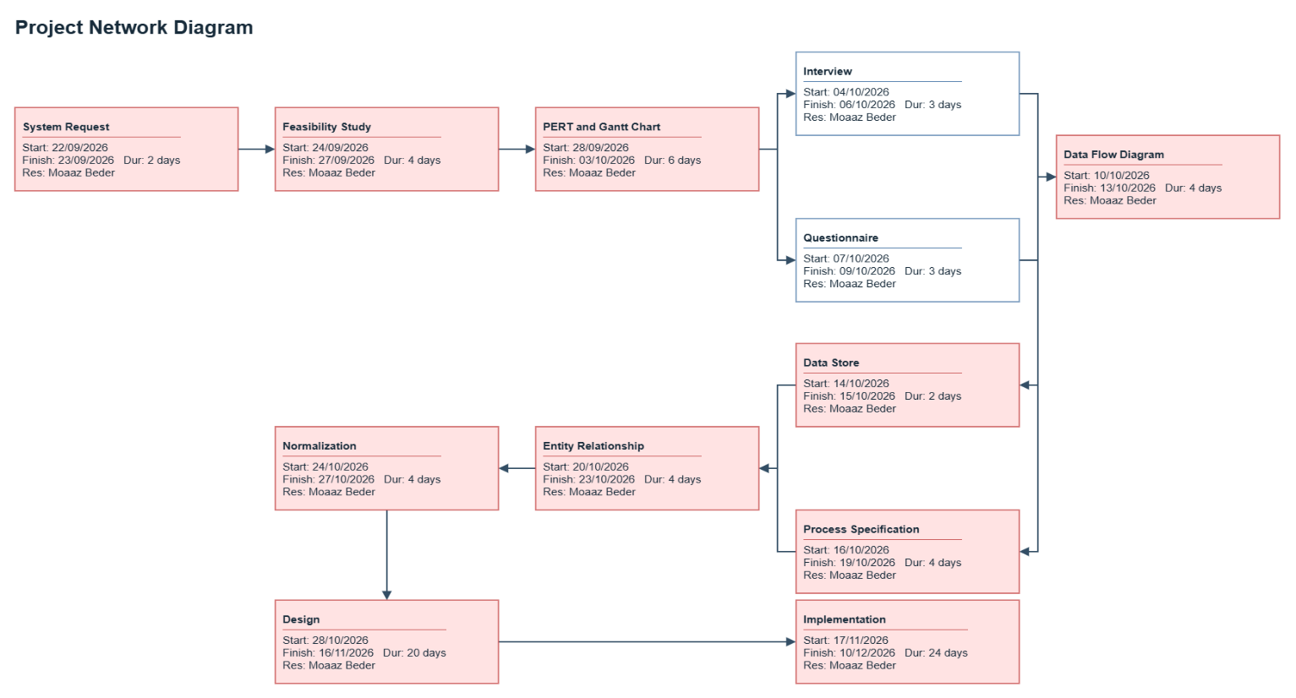
Gantt chart

Analysis (Project Proposal)

Interview
(include questions and answers)

